**Project 2**

**Programming for Procedural Game Content**

|  |  |
| --- | --- |
| Class (P01/P02/P03) |  |
| Matric # |  |
| Name |  |
| Project Option (1/2/3) |  |

**Unity project zip file url:**

|  |
| --- |
|  |

**Gameplay Instructions (how to control the player, etc.)**

|  |
| --- |
|  |

***Delete all RED text before submission***

**Note: Use the word count suggested in the requirements document as a guide – but it is okay if you go slightly beyond the stated maximums.**

**Also note that there will NOT be any presentation! Just submit your report.**

**1. Screenshots**

* Add a screenshot for each pattern that you use.
* Give each pattern a name (if there’s no formal mathematical name, you can make one up).
* Each screenshot must be the same size.
* All screenshots must fit on at most two pages.
* Make sure that your image layout is neat!

Something like this is good (to show how all the patterns relate):

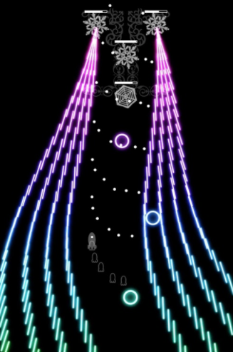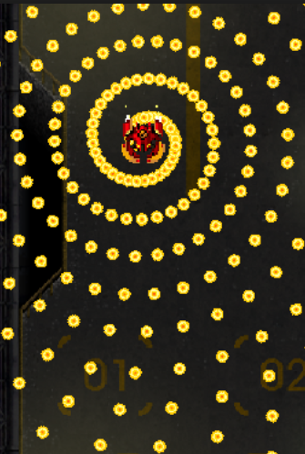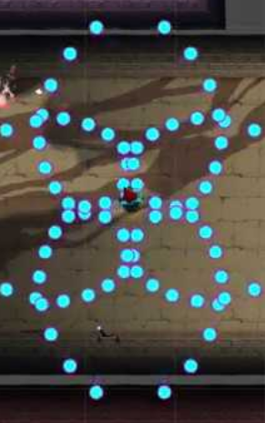

Pattern name Pattern name Pattern name



Pattern name Pattern name Pattern name

**2. Discussion about each pattern**

For each pattern:

* Give a small reminder image of the pattern
* State if the pattern is generated by a particle system or separate script(s)
* Discuss the following (pros and cons):

**Challenge** – what makes this pattern challenging from a playability point of view? This should not just be difficulty in terms of speed and number of bullets, but should be a more careful consideration of the pattern design and playability. You might discuss other features such as safety spots, bullet intelligence (if any), etc.

**Aesthetic appeal** – what decisions did you make about the colours, shape, animations, associated audio (if any) and other aesthetic aspects of this pattern? In other words, why do you think this pattern will be *appealing* to players?

**Future work** – what changes could be made to the pattern to make it more fun, challenging, and appealing?

**3. Discussion about game progression**

Discuss the following:

**Sequencing** – using a small image of each pattern, show the sequence of patterns as the game is played.

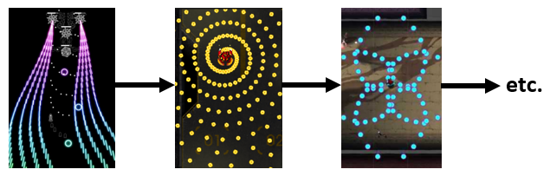

**Game progression** – how does each pattern further the gameplay progression of the game? In other words, how does each pattern fit into the game *flow* illustrated above? You might want to discuss pattern challenge, pattern similarity/contrast, pre and post pattern events (if any), and higher-level design concept you might have, etc.

**Intelligent design** – what do *you* think this means, and how have you applied it?

**4. Reflection**

Discuss the following:

**Initial thoughts** – what were your initial thoughts and plan(s) when informed about the project topic?

**Problems** – what conceptual and/or technical problems did you face, and how did you overcome them?

**Learning** – what have you learned from completing this project? You may discuss the main design, technical and personal aspects of your learning.

**5. Review of an existing bullet hell game**

Discuss the following:

**Brief description** – give a brief description of what you feel are the important points about the game. Give three small screenshots of the gameplay or other aspects of the game. The size of each screenshot should be similar to this:



**Differentiation** – how does this game try to differentiate itself from other bullet hell games? You might want to discuss the game’s high concept (if any), visual style, audio, narrative (if any), interaction with the player during gameplay, etc.

**Success** – how successful or not do you think this game is, and why?

**IMPORTANT!**

**You must include a list of references at the end of your report.**

**Your report must be neatly formatted and easy to read!**